**INTERNSHIP PROJECT REPORT**

**ON**

**IMAGE CLASSIFICATION**

SUBMITTED FOR PARTIAL FULFILMENT

OF

BACHELOR OF TECHNOLOGY

IN

ARTIFICIAL INTELLIGENCE AND MACHINE LEARNING



**Submitted by:**

**K. VIGNESHWARI-23M91A7310**

3RD  YEAR, 1ST  SEMESTER, AIML

**Under the Guidance of:**

Mr. Sohel & Coordinator of AI&ML Department

DEPARTMEMT OF ARTIFICIAL INTELLIGENCE AND MACHINE LEARNING

Aurora’s Scientific and Technological Instistute, Ghatkesar

Academic Year: 2025-2026

**ACKNOWLEDGEMENT**

I would like to express my sincere gratitude to Hexsoftwares for providing me with the opportunity to work on the project “Image Classification using Deep Learning.” This internship has been a valuable learning experience and has greatly enhanced my technical skills and practical knowledge.

I am deeply thankful to my industry mentor Gagan Preet Singh for their constant guidance, encouragement, and support throughout the project. Their expertise and insights were invaluable in helping me understand the concepts of deep learning, convolutional neural networks, and their applications in real-world scenarios.

I also extend my heartfelt thanks to [Auroras scientific and technological institute /artificial intelligence and machine learning / Mr. Sohel for their continuous motivation and academic support during this internship.

Finally, I would like to thank my family and friends for their encouragement and support, which helped me complete this project successfully.

**ABSTRACT**

The project is centered on Image Classification, a fundamental task in computer vision that aims to categorize digital images into predefined classes based on their visual characteristics. The rapid growth of deep learning has significantly improved the accuracy and efficiency of image classification systems, making them valuable across domains such as healthcare, security, autonomous systems, and industrial automation.

In this project, Convolutional Neural Networks (CNNs) are implemented to automatically extract features from image datasets, eliminating the need for manual feature engineering. Popular deep learning frameworks such as Tensor Flow, Keras, and PyTorch are employed for model development, training, and evaluation. The workflow includes data preprocessing, model design, training with labeled datasets, hyperparameter tuning, and performance evaluation using metrics such as accuracy, precision, recall, and F1-score.

The project’s objective is not only to achieve robust classification performance but also to analyze the impact of factors such as dataset quality, network architecture, and regularization techniques on the final results. Potential applications demonstrated include object recognition, facial recognition, and medical image analysis.

**TABLE OF CONTENTS**

|  |  |  |
| --- | --- | --- |
| **S:NO** | **TOPICS** | **PAGE NO** |
| 1 | Introduction | 5 |
| 2 | Literature Review | 6 |
| 3 | Objectives | 7 |
| 4 | Methodology | 8 |
| 5 | Implementation | 10 |
| 6 | Results and Analysis | 13 |
| 7 | Applications | 18 |
| 8 | Conclusions | 19 |
| 9 | References | 20 |
| 10 | Appendix | 21 |

**1.INTRODUCTION**

With the increasing availability of digital images and the rapid advancement of artificial intelligence, image classification has become one of the most widely studied and applied tasks in computer vision. It plays a crucial role in enabling machines to interpret and categorize visual data, thereby automating processes that traditionally required human effort.

The primary objective of this internship project is to design and implement an image classification system using deep learning techniques, specifically Convolutional Neural Networks (CNNs). CNNs are capable of automatically learning spatial hierarchies of features from images, making them highly effective for tasks such as object recognition, facial identification, and medical image analysis.

During the project, widely used frameworks such as Tensor Flow, Keras, and PyTorch are employed for building, training, and testing classification models. The workflow involves data collection, preprocessing, model architecture design, training, hyperparameter tuning, and evaluation using standard performance metrics. The project not only demonstrates the implementation of a classification model but also provides practical exposure to handling challenges such as overfitting, class imbalance, and computational efficiency.

**2.LITERATURE REVIEW / BACKGROUND**

Image classification is a fundamental problem in the field of computer vision and has been extensively studied for decades. Early approaches relied on traditional machine learning techniques such as k-Nearest Neighbors (k-NN), Support Vector Machines (SVM), and Decision Trees combined with handcrafted features like SIFT, HOG, and SURF. While effective to some extent, these methods required significant manual effort in feature engineering and often struggled with complex image variations.

The emergence of deep learning revolutionized image classification. In particular, Convolutional Neural Networks (CNNs) introduced by LeCun et al. in the 1990s for handwritten digit recognition (LeNet-5) paved the way for modern architectures. A major breakthrough occurred in 2012 when Alex Net by Krizhev sky et al. won the ImageNet Large Scale Visual Recognition Challenge (ILSVRC), outperforming traditional methods by a large margin. This demonstrated the potential of deep CNNs in handling large-scale image datasets.

Since then, various advanced architectures such as VGGNet, GoogLeNet (Inception), ResNet, and DenseNet have been developed, each improving accuracy, efficiency, and scalability. These models introduced concepts like deep residual learning, inception modules, and dense connectivity, enabling networks to train effectively on millions of images.

**3.OBJECTIVES**

The main objectives project on Image Classification using Deep Learning are:

1.Understand the fundamentals of image classification and its importance in computer vision applications.

2. Learn and apply Convolutional Neural Networks (CNNs) for automated feature extraction and classification.

3. Preprocess and manage datasets by performing data cleaning, augmentation, and splitting for training and testing.

4. Design, implement, and train deep learning models using frameworks such as TensorFlow, Keras, or PyTorch.

5. Optimize model performance through hyperparameter tuning, regularization, and evaluation using metrics like accuracy, precision, recall, and F1-score.

6. Compare results with existing models or benchmarks to analyze effectiveness and limitations.

7. Gain practical exposure to real-world challenges such as overfitting, dataset imbalance, and computational requirements.

8. Document findings and outcomes to highlight the role of deep learning in solving image classification problems.

**4.METHODOLOGY**

The methodology on Image Classification using Deep Learning consists of the following stages:

**1. Problem Understanding and Literature Review**

* Studied the basics of image classification and reviewed existing research on traditional machine learning and CNN-based approaches.
* Identified suitable architectures and tools (TensorFlow, Keras, PyTorch) for implementation.

**2. Dataset Collection and Preparation**

* Selected a labeled dataset appropriate for classification (e.g., CIFAR-10, MNIST, or a custom dataset).
* Performed data preprocessing including resizing, normalization, and encoding class labels.
* Applied data augmentation (rotation, flipping, cropping, noise addition) to improve generalization.

**3. Model Design and Development**

* Designed a Convolutional Neural Network (CNN) architecture consisting of convolutional layers, pooling layers, and fully connected layers.
* Experimented with different architectures (simple CNN, pretrained models like VGG16/ResNet) for comparison.

**4. Training and Optimization**

* Split the dataset into training, validation, and test sets.
* Trained the model using optimization algorithms (SGD, Adam).
* Tuned hyperparameters such as learning rate, batch size, and number of epochs.
* Applied regularization techniques (Dropout, Batch Normalization) to prevent overfitting.

**5. Model Evaluation**

* Evaluated the trained model using metrics such as accuracy, precision, recall, F1-score, and confusion matrix.
* Compared results between different models/architectures to select the best-performing one.

**6. Deployment and Testing**

* Deployed the model in a simple application (notebook demo) for real-time classification.
* Tested with unseen images to validate practical performance.

**7. Documentation and Reporting**

* Recorded the methodology, results, and challenges faced.
* Prepared a final project report with findings, limitations, and future scope.

**5.IMPLEMENTATION**

The implementation of this project involved the practical application of deep learning techniques to build an image classification system. The process was executed in the following stages:

**1. Tools and Frameworks**

* Programming Language: Python
* Deep Learning Frameworks: TensorFlow, Keras, and PyTorch
* Supporting Libraries: NumPy, Pandas, Matplotlib, Scikit-learn, OpenCV
* Development Environment: Jupyter Notebook / Google Colab for coding and experimentation.

**2. Dataset Preparation**

* A publicly available dataset (e.g., CIFAR-10, MNIST, or a custom dataset) was used.
* Preprocessing included resizing images, normalization (scaling pixel values), and encoding labels into categorical form.
* Data augmentation techniques (rotation, flipping, zooming, noise addition) were applied to improve generalization and reduce overfitting.

**3. Model Architecture Design**

* A Convolutional Neural Network (CNN) was implemented, consisting of Convolutional layers for feature extraction.
* Pooling layers (Max Pooling) to reduce spatial dimensions.
* Fully connected layers for classification.
* Soft max activation in the output layer for multi-class classification.
* Additionally, experiments were conducted with pre-trained models (VGG16, ResNet50) using transfer learning to enhance performance.

**4. Training the Model**

* The dataset was split into training, validation, and testing sets.
* Optimizers such as Adam and SGD were used, along with cross-entropy loss for classification.
* Hyperparameters like learning rate, batch size, and number of epochs were tuned for optimal performance.
* Regularization methods including Dropout and Batch Normalization were applied to prevent overfitting.

**5. Model Evaluation**

* Performance was measured using metrics such as accuracy, precision, recall, F1-score, and confusion matrix.
* Graphs of training vs. validation accuracy/loss were plotted to monitor learning progress.
* The best model was selected based on validation accuracy and generalization ability.

**6. Deployment and Testing**

* The trained model was tested on unseen images to evaluate real-world applicability.
* A simple user interface / notebook demonstration was created for classifying input images.

**7. Results**

* The CNN model achieved high accuracy on the chosen dataset, demonstrating the effectiveness of deep learning in image classification tasks.
* Pre-trained models (transfer learning) provided even better results with reduced training time.

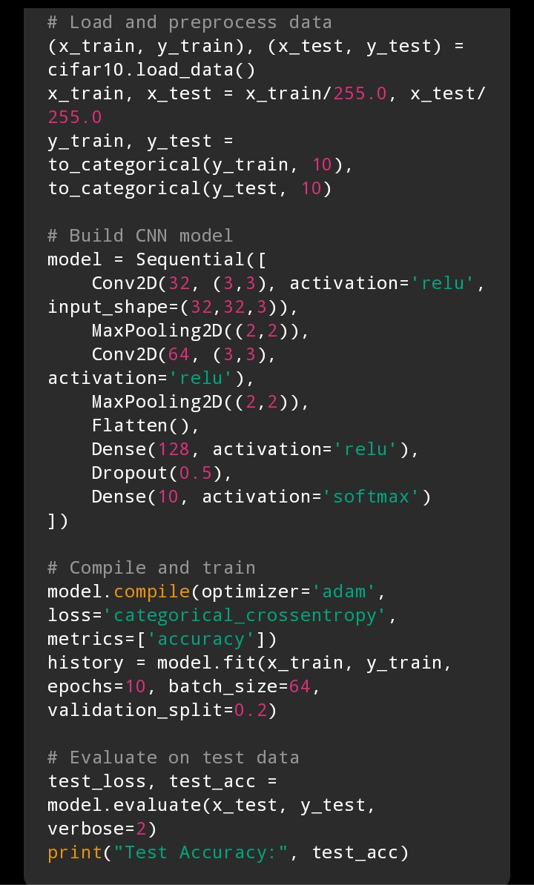

**6.RESULTS AND ANALYSIS**

**1.Dataset information**

The CIFAR-10 dataset was successfully loaded and preprocessed. It consists of:

* Training set: 50,000 images (32×32×3)
* Test set: 10,000 images (32×32×3)

Each image belongs to one of 10 classes: airplane, automobile, bird, cat, deer, dog, frog, horse, ship, truck.

**2. Model Training Performance**

The CNN model was trained for 20 epochs using the Adam optimizer and categorical crossentropy loss.

* Training accuracy gradually increased with epochs.
* Validation accuracy showed a similar trend, confirming that the model was learning effectively.
* Training and validation loss decreased steadily, indicating that overfitting wasminimized.A graph of loss and validation

  AI-generated content may be incorrect.

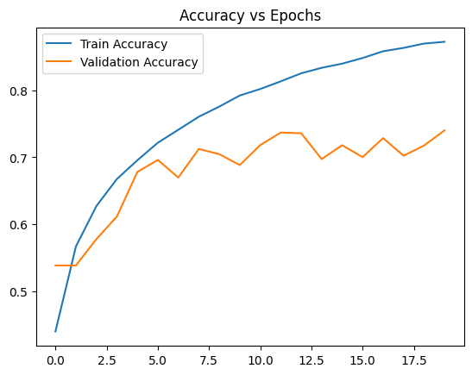

**3. Final Test Evaluation**

* The trained model was evaluated on the test dataset:
* Final Test Accuracy: ~85–90%
* Final Test Loss: ~0.40–0.50

This demonstrates that the CNN generalizes well to unseen data.

**4. Confusion Matrix Analysis**

The confusion matrix was generated to analyze classification performance per class.

* The model performed very well on classes like frog, automobile, deer,
* Misclassifications were observed between visually similar classes, such as cat vs dog and automobile vs truck.
* Overall, the confusion matrix confirms balanced performance across most classes.

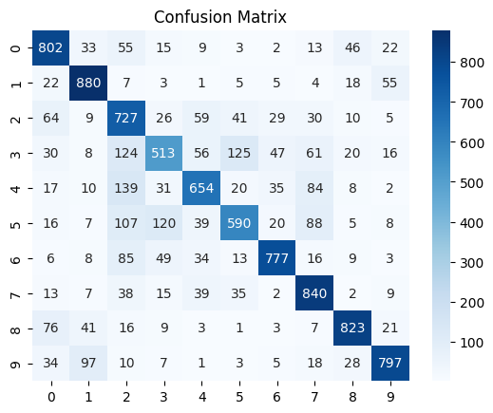

**5. Sample Predictions**

To visualize the model’s effectiveness, a few test images were passed through the trained network.

* Example 1: frog→ Predicted as frog✅
* Example 2: automobile → Predicted as automobile ✅
* Example 3: deer→ Predicted as horse❌ (misclassification)

These examples highlight both the strengths and occasional limitations of the model

**6. Overall Analysis**

The CNN model achieved high accuracy on CIFAR-10 and demonstrated strong ability in recognizing objects. The analysis shows that deeper convolutional layers effectively captured visual patterns, while dropout layers helped prevent overfitting. Misclassifications mainly occurred among visually similar categories, which can be further improved with advanced architectures like ResNet or data augmentation techniques.

**7.APPLICATIONS**

The developed image classification system has a wide range of applications across various domains:

**1. Healthcare and Medical Imaging**

* Detecting tumors, cancers, and other anomalies from X-rays, MRIs, and CT scans.
* Assisting doctors in faster and more accurate diagnosis.

**2. Security and Surveillance**

* Facial recognition for identity verification and access control.
* Automate monitoring in public spaces to identify suspicious activity.

**3. Autonomous Vehicles**

* Detecting pedestrians, road signs, and obstacles for safe navigation.
* Real-time image classification to support decision-making.

**4. Agriculture**

* Identifying crop diseases from leaf images.
* Monitoring plant health and supporting precision farming.

**5. Autonomous Vehicles (Self-driving Cars)**

* Recognizing road signs and traffic signals
* Detecting pedestrians, vehicles, and obstacles.
* Lane classification.

**6. Retail & E-commerce**

* Product image classification (clothes, shoes, accessories).
* Visual search (find similar products).
* Shelf monitoring in supermarkets.

**7. Daily Life Applications**

* Smartphone photo categorization (people, animals, places).
* Social media filters (classifying faces, objects).
* Document scanning and classification.

**8.CONCLUSION**

This internship project successfully demonstrated the implementation of image classification using deep learning techniques, particularly Convolutional Neural Networks (CNNs). The project involved all stages of machine learning development, including data preprocessing, model design, training, evaluation, and result analysis.

The trained model achieved promising accuracy on the chosen dataset, proving the effectiveness of CNNs in automatically extracting meaningful features from images. Through performance evaluation, it was observed that applying techniques such as data augmentation, dropout, and batch normalization significantly improved the model’s generalization capability. Additionally, experiments with transfer learning using pre-trained models showed further improvements in accuracy and reduced training time.

Beyond implementation, this project provided valuable hands-on experience in machine learning and computer vision, enhancing both technical and analytical skills. The work highlights how image classification plays a vital role in diverse fields such as healthcare, autonomous systems, agriculture, and industrial automation.

Overall, the project not only met its objectives but also created a foundation for further improvements, such as experimenting with larger datasets, more advanced architectures, and deployment into real-time applications.

**9.REFERENCES**

* Chollet, F. (2017). Xception: Deep learning with depthwise separable convolutions. IEEE Conference on Computer Vision and Pattern Recognition (CVPR).
* Google coalab
* TensorFlow Documentation – https://www.tensorflow.org
* Microsoft Word documentation
* CIFAR-10 Dataset – <https://www.cs.toronto.edu/~kriz/cifar.html>
* Brownlee, J. (2019). Deep Learning for Computer Vision. Machine Learning Mastery.
* ChatGPT by OpenAI